|  |  |
| --- | --- |
| **Digital Forensics**  Diploma in ISF/IT  Year 2/3 (2019/20) Semester 4/6 | Week 2 |
| Practical 3 |
| **Searching and Bookmarking** | |

**OBJECTIVES**

To be able to perform:

1. Searching using keywords.
2. Bookmarking data found in search hits.

Preparation: (the following steps must be performed each time you use EnCase.)

1. Boot the computer to Windows 7.
2. Ensure that the Windows Firewall and Symantec Anti-virus are turned off.
3. Enable the wired network adapter and set the IP address to dynamically assigned, then disable the wireless network adapter.
4. Ping 10.1.0.1 and ensure that you receive reply from the SAFE server.
5. Start EnCase application.
6. You should see the panel showing “**EnCase Forensic Training**” rather than “EnCase Acquisition”.
7. Refer to the case write-up on Conspiracy.
8. Tutor will be providing the evidence files: ***Laura.EXX***

**If you still do not see “EnCase Forensic Training”, inform your tutor.**

**Adding Evidence Files to a Case**

**Refer to Week 1 Practical 1 for detailed steps.**

Create a new case in EnCase. Name the case as *Laura*.

*Note: It is not necessary to add files E02, E03, E04 etc. as they are added automatically by EnCase.*

**Part A: Searching the Case**

EnCase provides a powerful search engine to locate information anywhere on the physical or logical media. After creating a case file, a raw keyword search operation may be conducted. The method of query detailed is called “raw keyword searching”. It bears this name because certain words or string text is used to search against raw binary evidence data. Keywords may be created with various options.

Within Encase, there are different methods to conduct a raw keyword search. It depends on the data set against which you want to focus your keyword searching. Encase allows raw keyword searching against all evidence, just selected evidence or a narrowed down result set.

We shall concentrate on searching by selected evidence using Raw Search Selected (i.e. a raw keyword search against blue checked or selected items).

Q1. Explore 3 different ways in which you can create raw keyword searching. (You may need your tutor’s help)

1. Keyword Search
2. Raw search all
3. Searching in the evidence browser on blue-checked file (using Raw search All); Raw search selected

Adding Keywords

Always create an appropriate keyword list prior to beginning the case.

In Encase, at the Evidence Viewing (Entry) page, blue-check D 🡪Users 🡪 encase01. Then click the **Raw Search Selected** menu. This will allow keyword (s) to be added under the **New Raw Search Selected**.

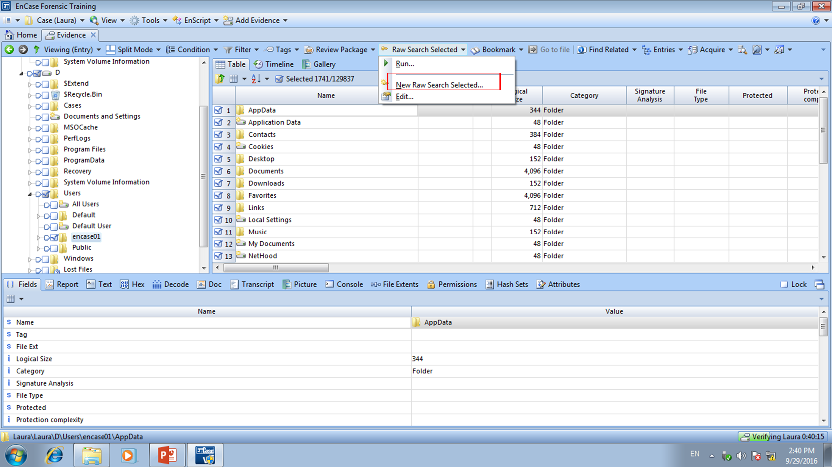

Figure A-1: “New Raw Search Selected in Evidence view

Note that the default location for saving this keyword file is within the User’s Document\ Encase\Search\ folder (.Keywords). You can rename your keyword search folder. Once you have built your investigative keyword files, you can easily run them from the Raw Search Selected menu with future cases.

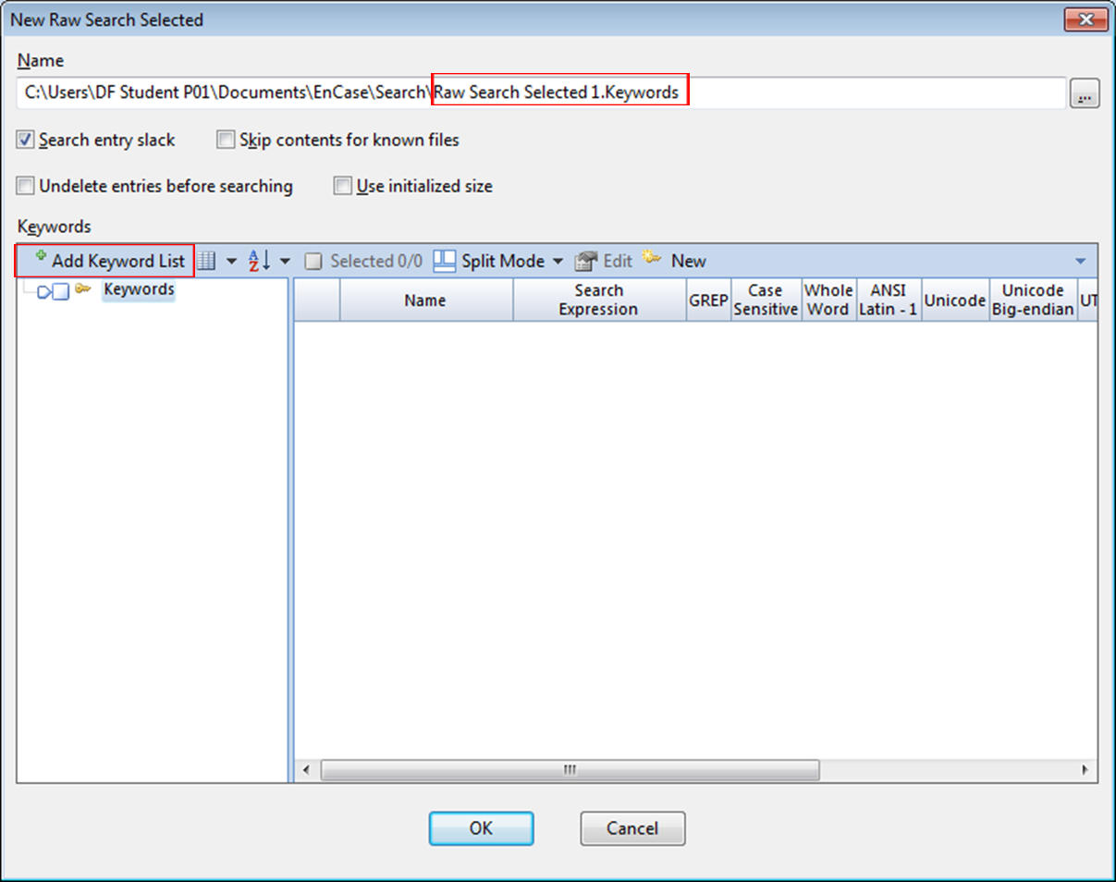

Figure A-2: New Raw Search Selected Window

The searching functions are listed as follows:

* Search entry slack
* Skip contents for known files
* Undelete entries before searching.
* Use initialized size

(For this exercise, tick the **Search entry slack)**

To perform only a single entry search, select the **New** button. This will bring up the **New Keyword** entry screen as shown below:

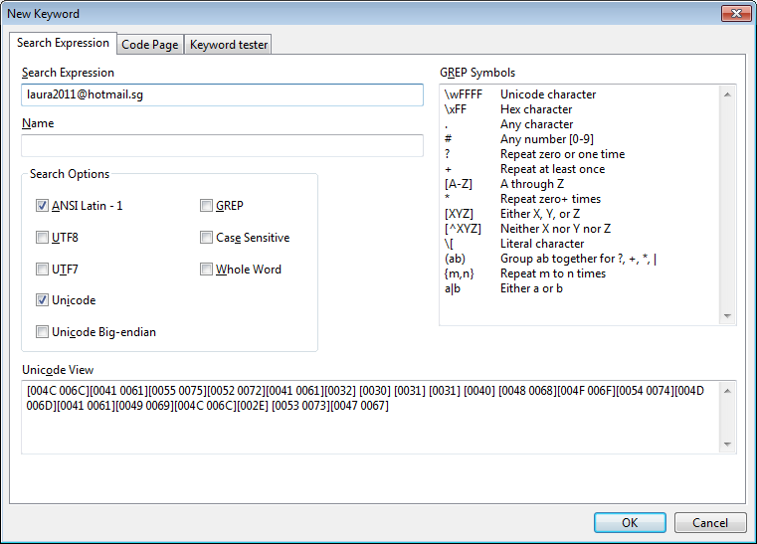

Figure A-3: Entering a Single Keyword

Enter Laura’s email address as keyword: [laura2011@hotmail.sg](mailto:laura2011@hotmail.sg) in the Search Expression field and Name it as Laura Wright. Select the rest of the options as shown in Figure A-3.

Explore the following options which can be set from this window:

* **ANSI Latin -1** – The default option will search for characters within the ANSI Latin-1 code page, which is the default code page for the Microsoft Windows operating system.
* UTF-8 – This is the 8-bit for of Unicode. It offers foreign language support. (more for HTML)
* UTF-7 – UTF-7 is a special format that encodes Unicode characters within US-ASCII in a way that all mail systems can accommodate. (more for emails)
* **Unicode** – Most MS Office products use Unicode as does Windows 2000, XP and Vista. *Enabling both ANSI Latin-1 and Unicode option will locate both ASCII and Unicode characters.*
* Unicode Big-Endian
* GREP – The GREP option must be selected when utilizing GREP search characters. GREP is used to narrow the search, limit false positive search hits, and in those cases where only certain portions of the keyword being sought are known.
* Case Sensitive
* Whole Word – EnCase will locate the keyword as a whole word not within a larger word.

Q2. We have selected Unicode and ANSI Latin -1 in our search options. What selections would you make if you are searching for Chinese characters found in an email message?

I will use UTF-8 and Unicode

Click **OK** and **OK** again at the Keywords window will start the keyword searching…

Searching updates can be seen at the lower right corner.

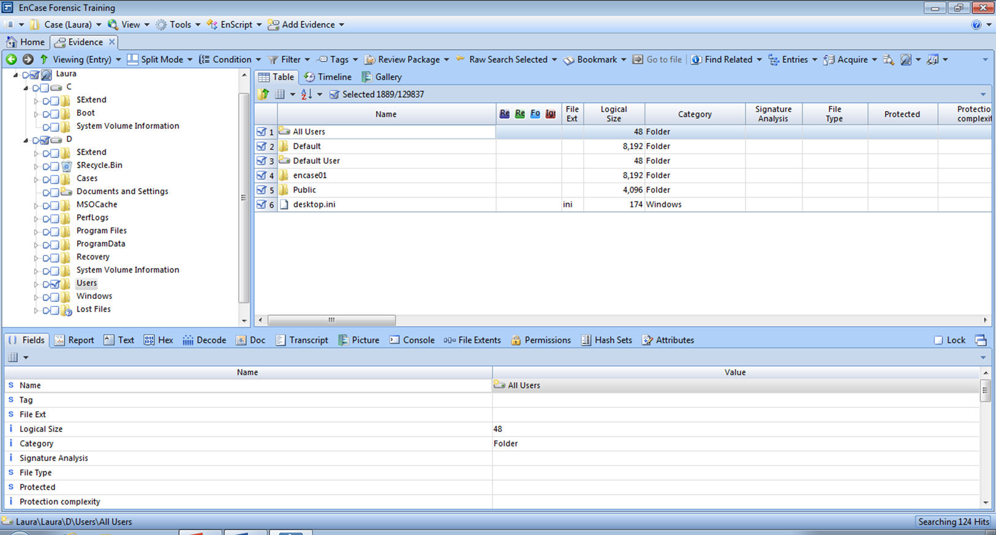

Figure A-4: Keyword Search Status

The keyword you have created will also be saved to the .Keywords file you named. (Default location for saving this keyword file is within the User’s Document\ Encase\Search\ folder (.Keywords). )

After Keyword Searching is Complete

The Result tab will automatically open upon completion of the search process. This tab is where you are initially taken to review the keyword search hits.

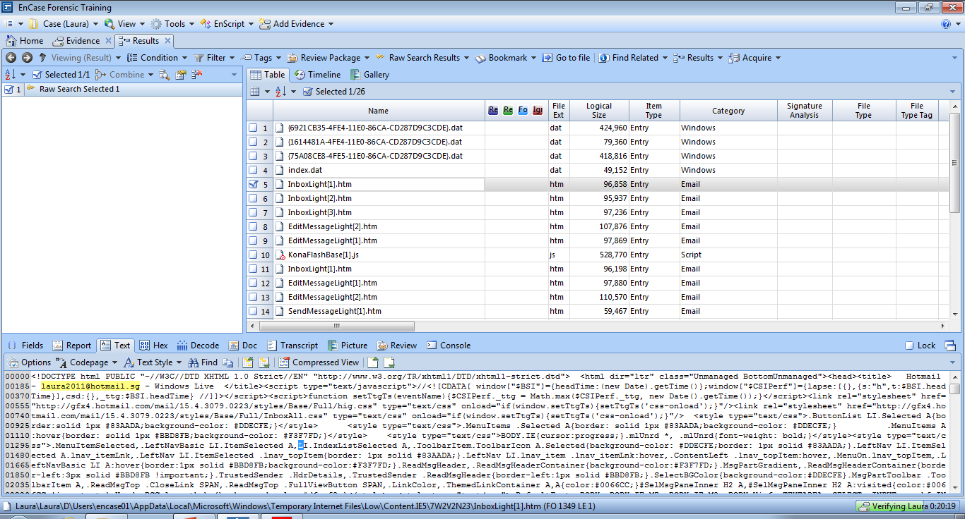



Figure A-5: Keyword Search Results

You can change the name of your keyword search either by double-click the keyword or right-click at the keyword and select edit.

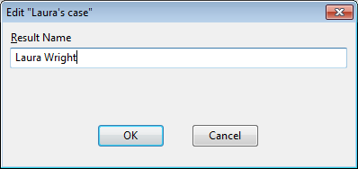

Figure A-6: Modifying Keyword Name

Viewing the Search Hits by Keyword

To view the search hits listed by the keyword, select **View** menu and choose the **Search** tab.

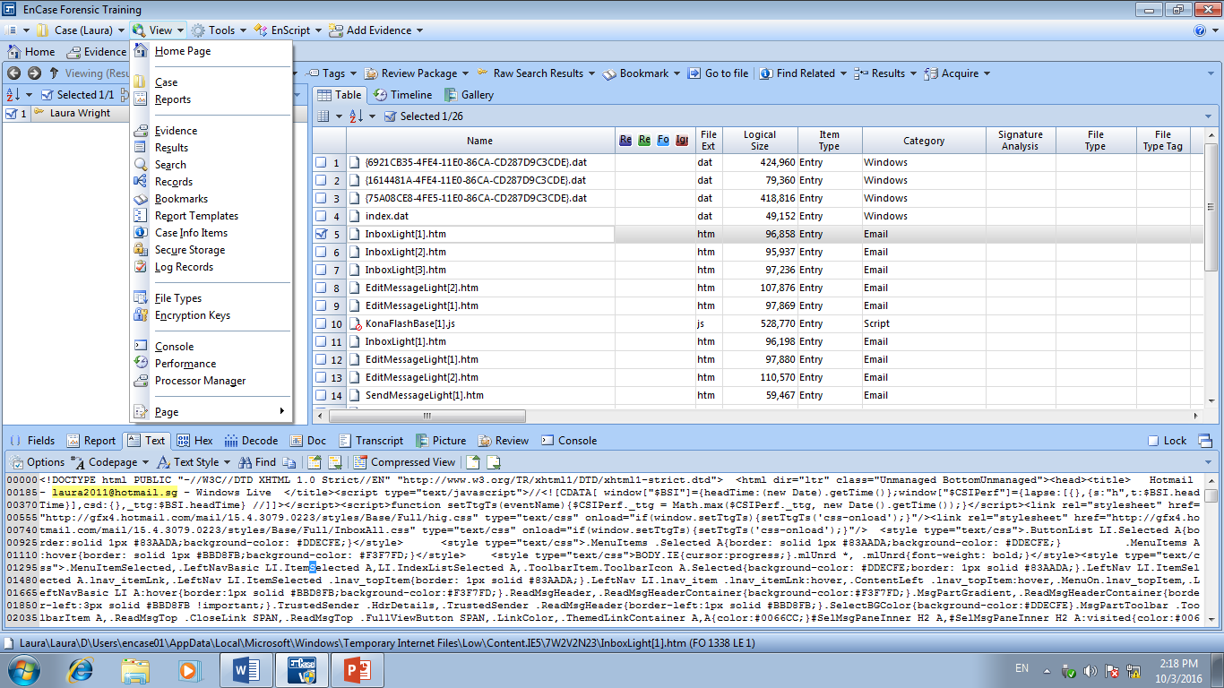

Figure A-7: Navigating to the Search Tab

Next, click on the tab with the yellow key icon. The search hits will be listed below by keyword.

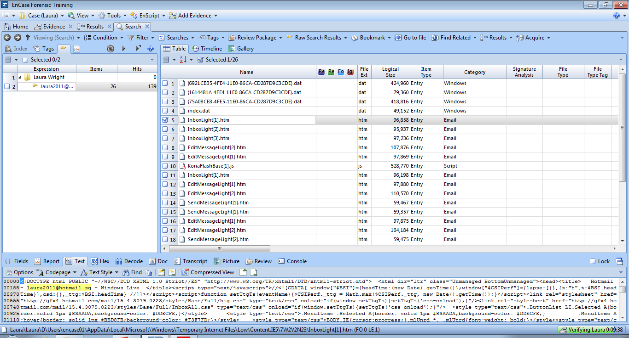

Figure A-8: Viewing Search Hits by Keyword

Reviewing Keyword Search Hits

The keyword search hits can be reviewed from either the Result tab or Search tab. The Result tab allows to with keyword searches but the keywords are combined together in one search results set. The Search tab allows to scan the responsive files by the keywords they contain.

At the Table view, the contents can be viewed in the Text tab of the View Pane. The search hits will be highlighted in yellow by default. (Essentially we are searching for raw text or ASCII code page representation of the binary stored on disk).

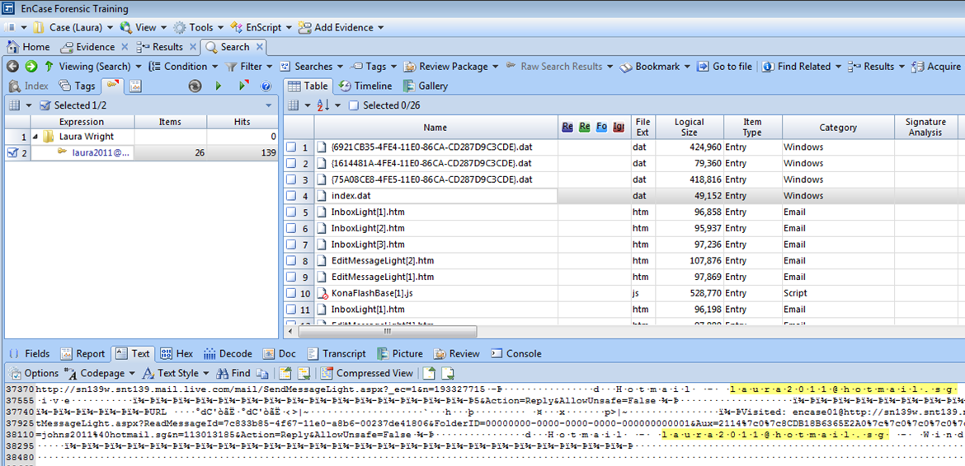

Figure A-9: Reviewing Search Hits by Keyword

The buttons to the left of the Compressed View (in the View Pane) are used to hop the view to the next search hits within the View Pane. As shown in Figure A-10, you can click the icons to move forward (Next Hit) or backwards (Previous Hit). Similarly, the buttons to the right of the Compressed View will move to the next responsive file (Next Item) and previous responsive file (Previous Item).

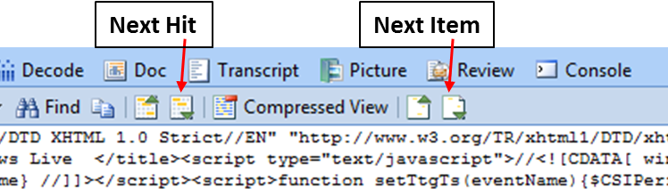

Figure A-10: Navigation Buttons

By clicking the Compressed View button, will show a truncated view of the keyword and the data before and after it. The keyword hit will be centred to allow as much text as possible on both sides for viewing in context.

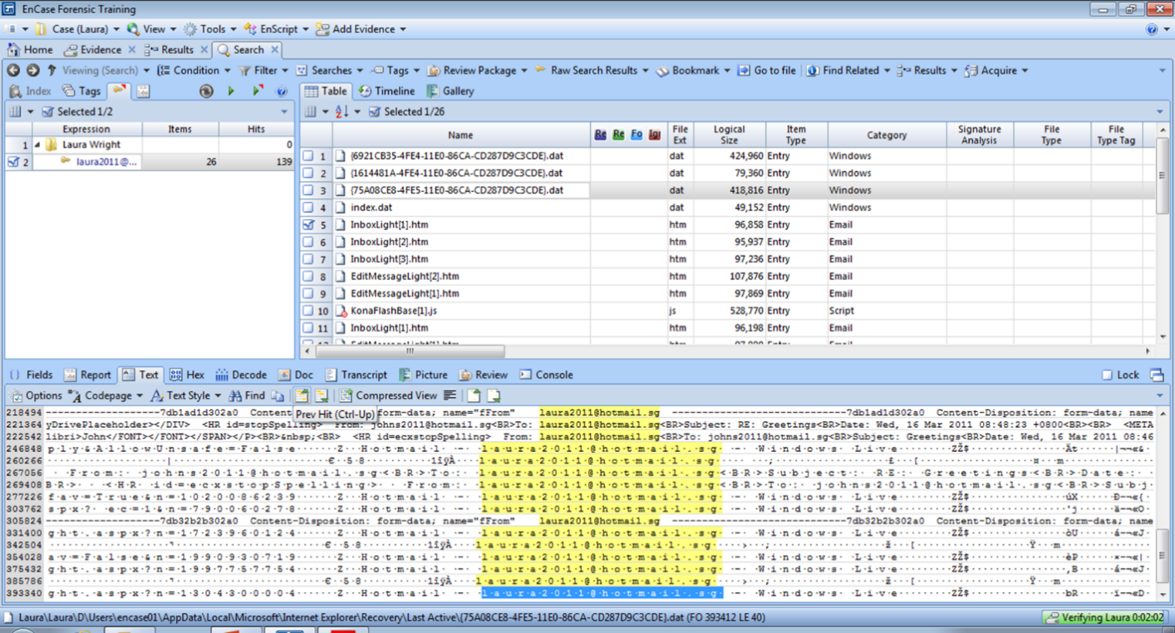

Figure A-11: Compressed View of Search Hits

[Note: You can also create a keyword list related to the investigation. This can be done by selecting **Add Keyword List.** at the **New Raw Search Selected** window. The Add Keyword List dialog box will appear:

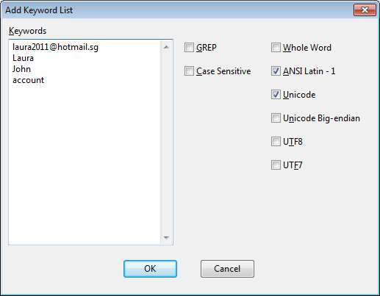

Figure A-12: Adding a Keyword List

[Explore and try this yourself.]

Q3. Other using email addresses as keywords, what other keywords can you use to search for the case?

Laura, mail, drafts, sent, spam, bin, flag, date

**Part B: Bookmarking**

EnCase allows the examiner to document files, sections of files, or other objects of interest within the case. This is referred to as *bookmarks*, and the folders where they are stored are bookmark folders. Bookmarks and the organization of their folders are essential to creating a solid and presentable body of case evidence. You can examine bookmarks closely for their value as case evidence, and additionally, use the bookmark folders and their data items to create case reports.

Understanding Bookmarks

There are several different types of bookmarks. The more common ones are mentioned here.

**Highlighted Data Bookmark** – Created by sweeping data. This is normally done through Raw Text bookmark and /or Data Structure bookmark

**Notable File Bookmark** – Use notable file bookmarks to mark one or more files. You can assign notable files into a bookmark folder either singly or as a selection of files.

**Notes Bookmark** – Allows the writing of comments into the Report.

Bookmarking Highlighted Data: Raw Text Bookmarks

To create a raw text sweeping bookmark:

1. In the Evidence tab, go to the Table pane and select the file containing the content you want to bookmark.
2. In the View pane, click the appropriate tab (Text, Hex, or Decode).
3. Highlight the raw text you want to bookmark.
4. On the menu bar, click **Bookmark 🡪 Raw text** or right click the highlighted text and click **Bookmark 🡪 Raw text**.

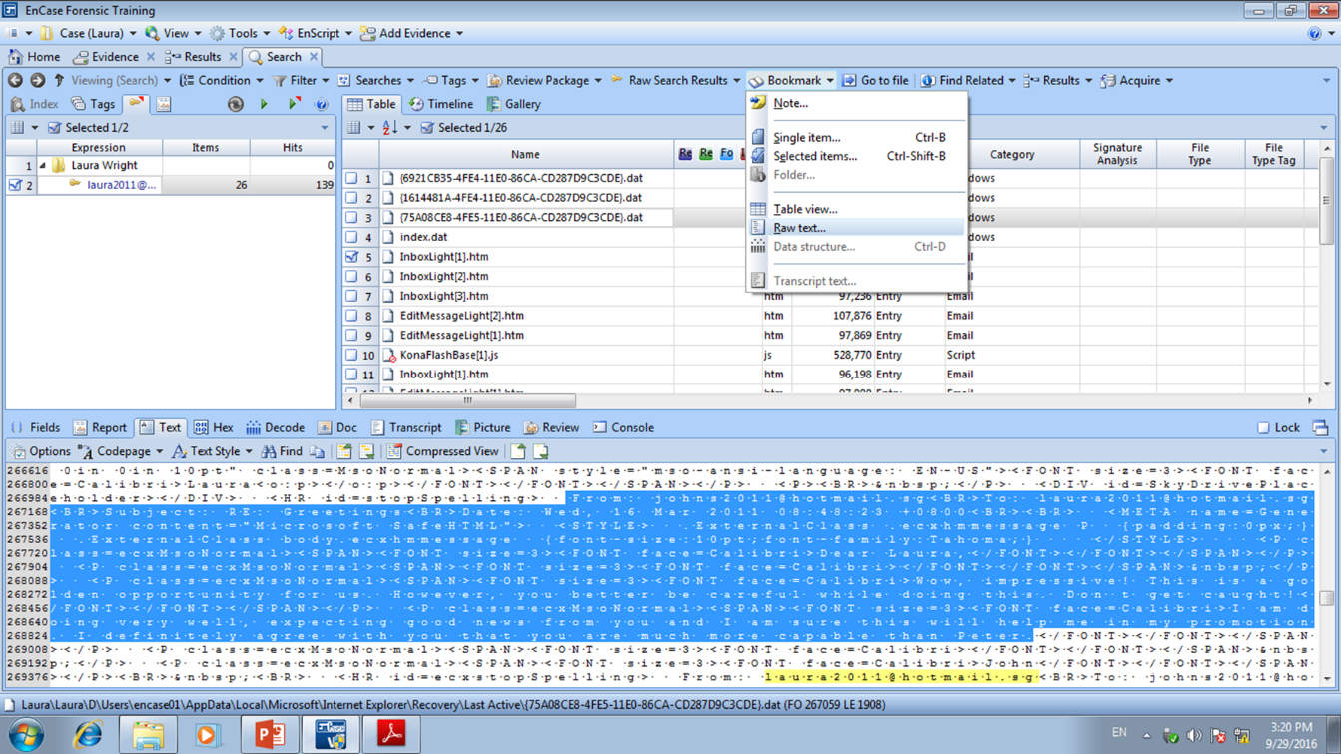

Figure B-1: Booking Raw Text

The Raw Text dialog displays. Type some identifying text in the Comments box on the **Properties** tab that makes it easy to identify the bookmarked content.

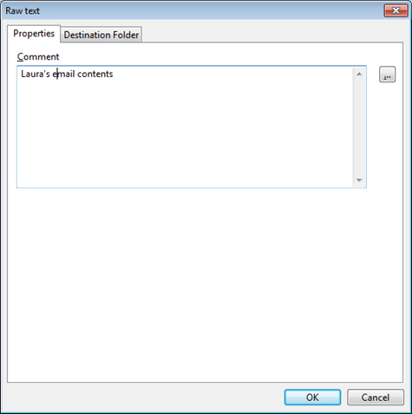

Figure B-2: Comment for Bookmark

Click the Destination Folder tab, which displays the bookmark folder hierarchy for the current case, and click the bookmark folder where you want to place this sweeping bookmark. You can either create a new folder or make use of one of the appropriate sub-folders. (Note that you can always rename bookmark folders or move the bookmark later).

Name the folder as “**Email Content**”. Click **OK** to create the bookmarked content in the folder.

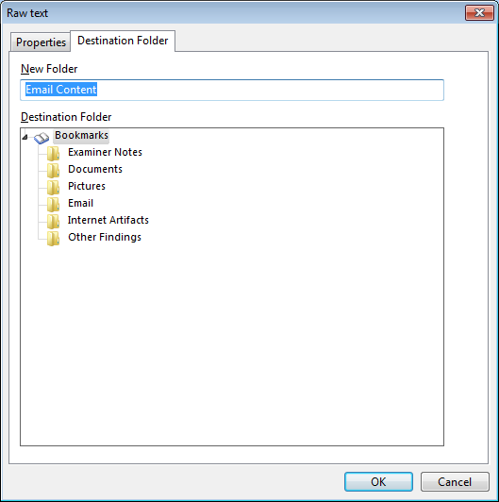

Figure B-3: Creating New Folder for Bookmark

By navigating to the **Bookmarks** tab through **View 🡪Bookmarks** and clicking on the newer created folder (i.e. Email Content), the raw bookmarked raw text in the Report tab of the View Pane can be seen:

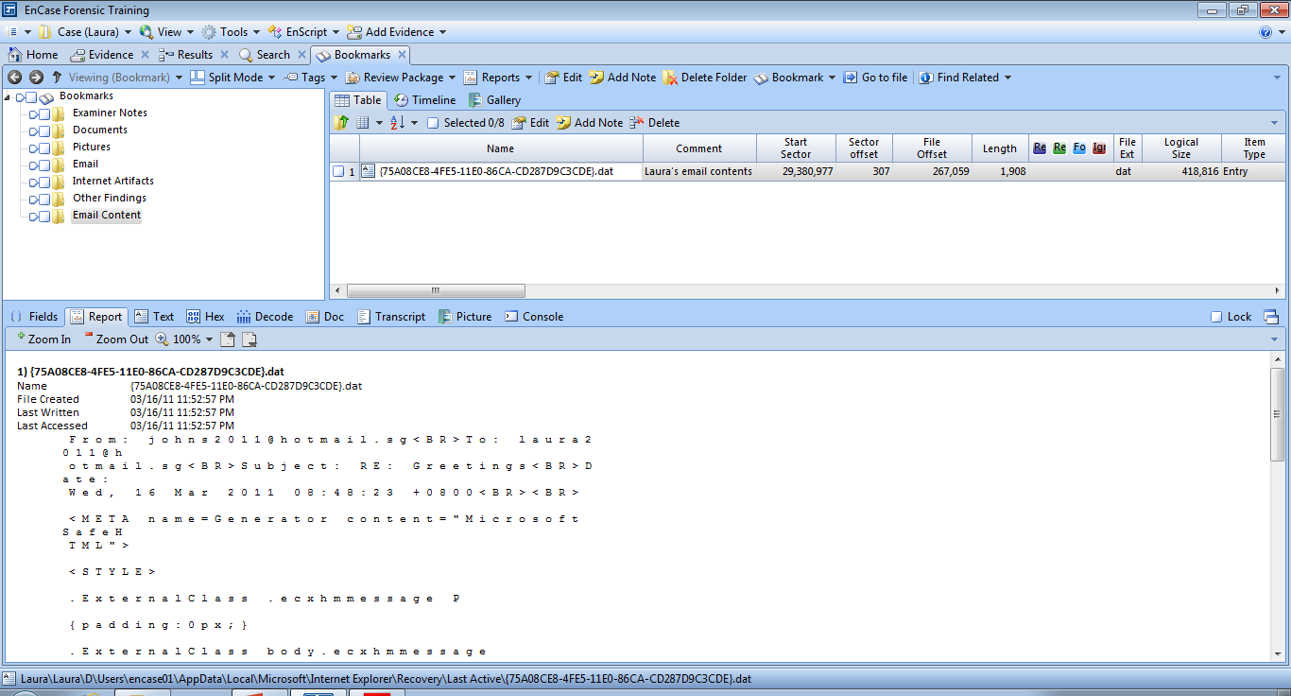

Figure B-4: Bookmarked Raw Text

Bookmarking Highlighted Data: Data Structure Bookmarks

Data structure bookmarks mark items such as a Windows partition entry, a Unix text date, or Base64 encoded text. This exercise describes one example of creating a sweeping data structure bookmark on a date/time data item.

To create a data structure bookmark:

1. Select the evidence item of interest from the Table pane of the Evidence tab.
2. Examine the file content in the View pane by clicking the appropriate tab. For the purposes of this example, we will assume that characters displayed in the pane are not in an easily readable format.
3. Click the Decode tab. The View Types tree displays inside the left part of the View pane.

 Figure B-5: Decode Tab – View Types

1. Since the examiner is investigating date/time data in this example, expand the Dates folder and click some of the options.

 Figure B-6: Dates Option

1. The HFS Plus Date option yields a satisfactory representation of the data, as shown below. ( You may wish to explore the other options )

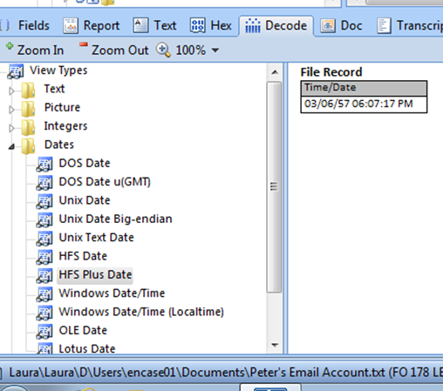 Figure B-7: HFS Plus Date Option

1. To bookmark the data, right click the HFS Plus Date node, and select Bookmark > Data Structure or on the menu bar, click Bookmark > Data Structure.

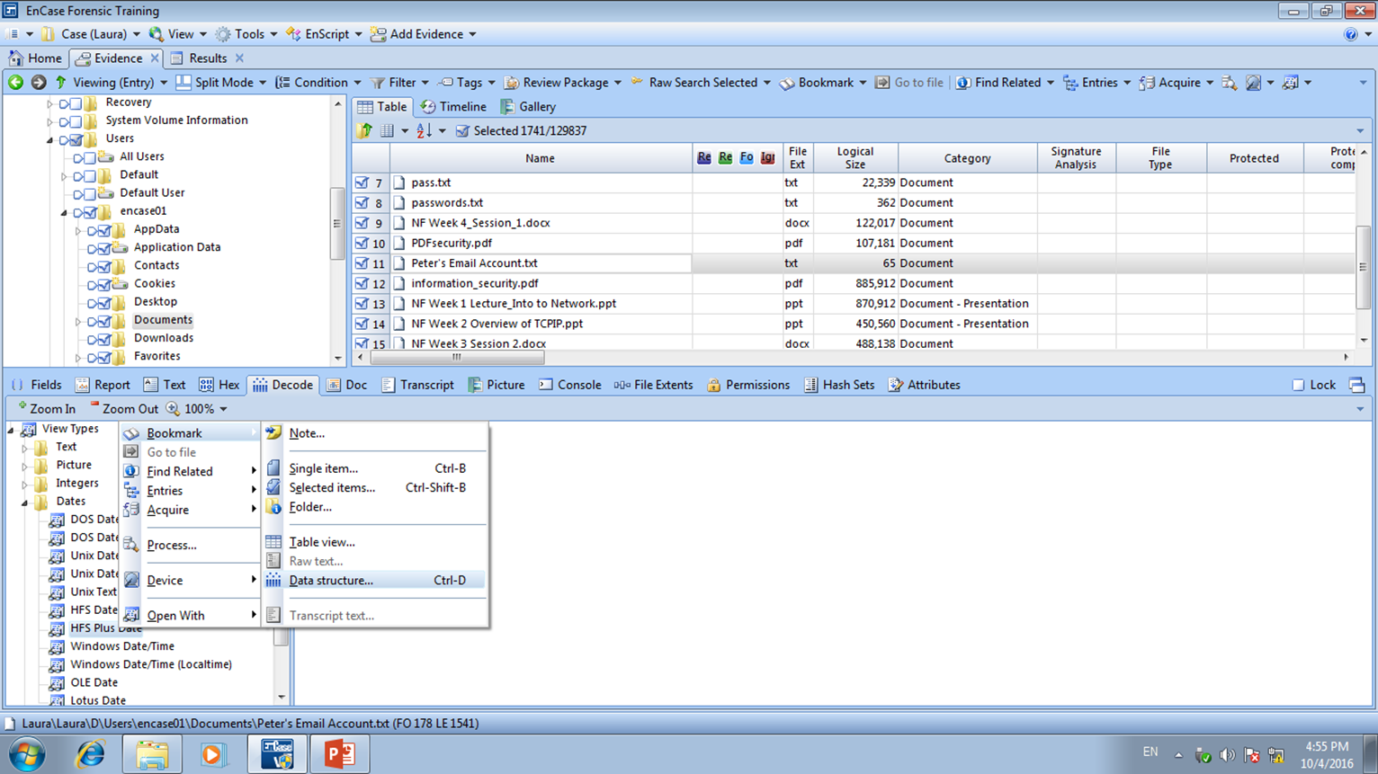

Figure B-8: Bookmark Data Structure

1. In the Data Structure dialog, type text about the data structure bookmark in the Comments box and click the Destination Folder tab.
2. In the Destination Folder box, click the folder where you want to store this data structure bookmark. Click **OK**.

Bookmarking a Notable File

Notable File bookmarks are used to identify individual files that contain important information to the current case. If the file is not an image file, the contents of the file will not be bookmarked. Only the administrative information about a non-image file is displayed in the report.

Single Notable File Bookmarks

To bookmark a single notable file:

1. From the appropriate tab, select the file of interest in the Table pane by clicking its row. Select Peter’s Email Account .txt.



1. On the toolbar, click **Bookmark > Single item**... (Note: Selected items can be used for selecting multiple notable files)
2. The Single item dialog opens. On the Properties tab, type some identifying text in the Comment. Alternatively, you can use the browse button to view a list of existing comments, and select one of those.
3. Click the Destination Folder tab to display the case's bookmark folder hierarchy. Click the bookmark folder where you want to store the bookmark. Click **OK.**

[You can also bookmark Notes, Pictures (Gallery), etc in the similar way. Try this out yourself]

Reflection: What have you learnt in this practical exercise?

We learn to perform many different search of evidence using keywords and how to bookmark it so we can find it easily next time.

Reference

• Guidance Software, Inc, EnCase Forensics – v7.11.

- The End -